Kali Linux Hard Disk Installation Guide

Introduction
This document explains how to install Kali Linux on a VMware workstation.

System Requirements
Minimum 2GB RAM (4GB recommended), 40GB disk space, VMware and ISO image of Kali Linux.

Steps
- Download Kali ISO
Downloaded Kali Linux ISO image from official website of Kali.org
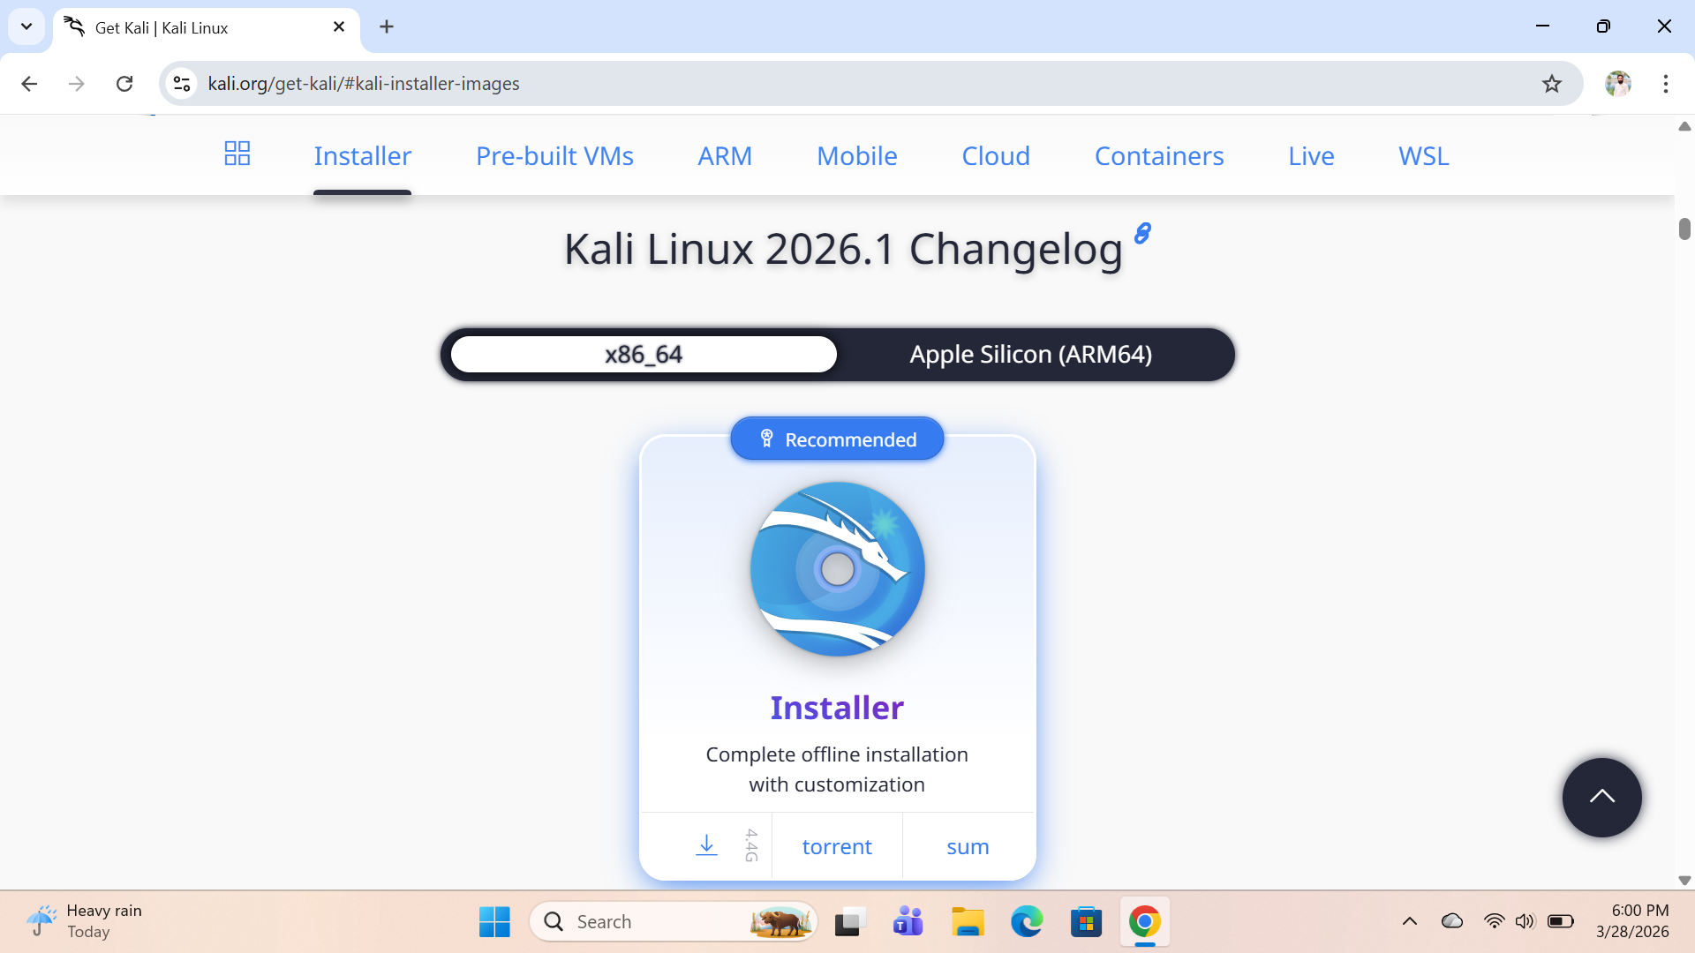

- Download VMware workstation
Downloaded VMware workstation from Broadcom.com website
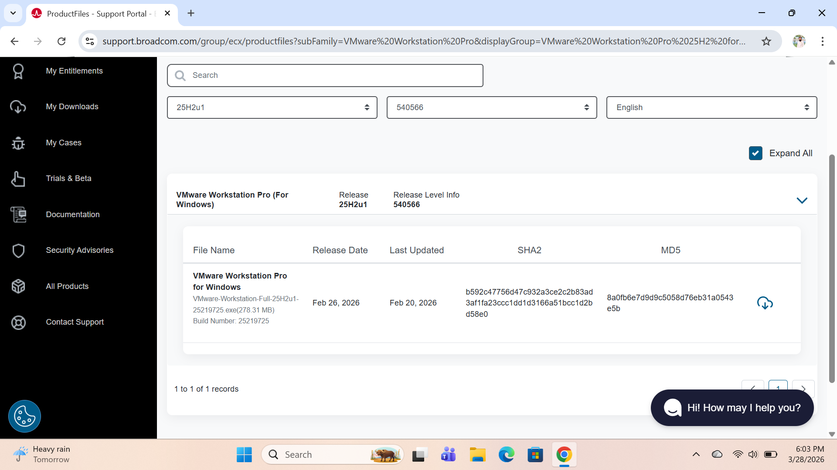

- Configuration of VMware workstation
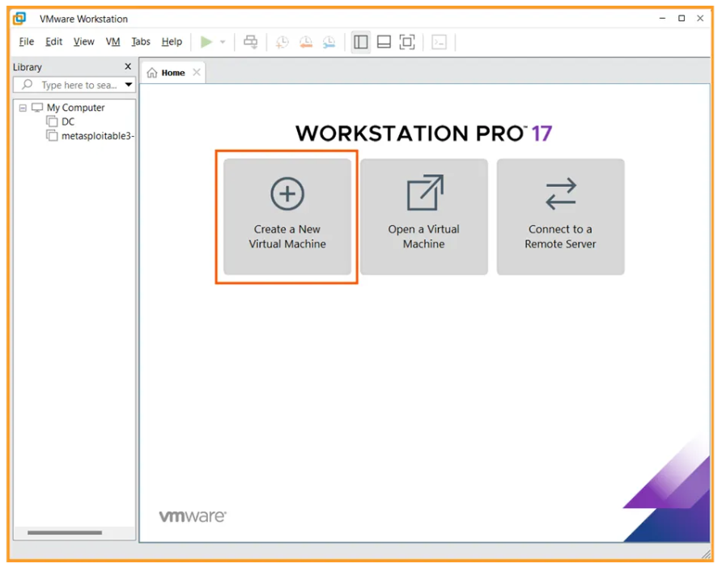
Open VMware workstation and create a new virtual machine.

Select Typical
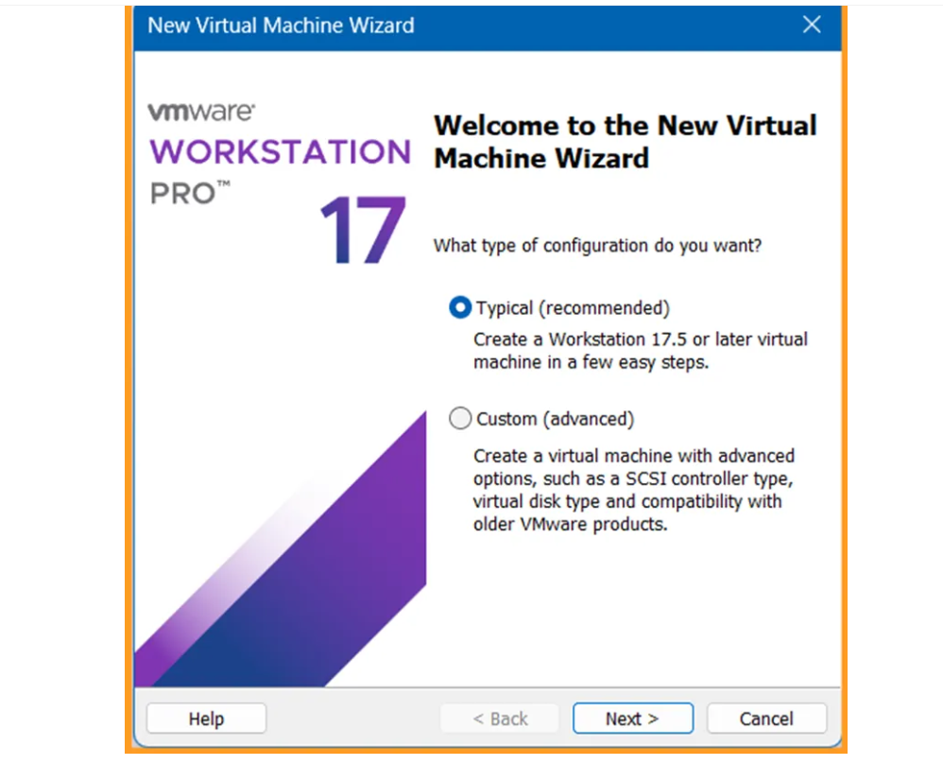
Now set all the specification according to the given
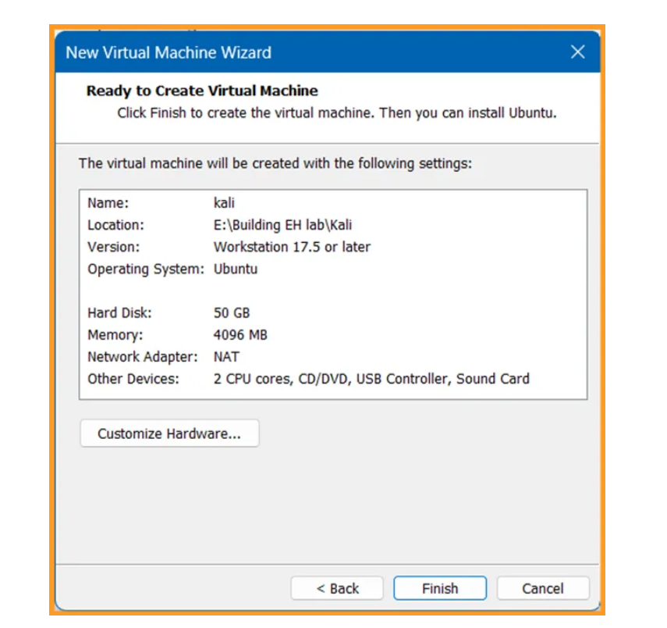
- Kali Linux Installation Process
Start created machine and select Graphical Install
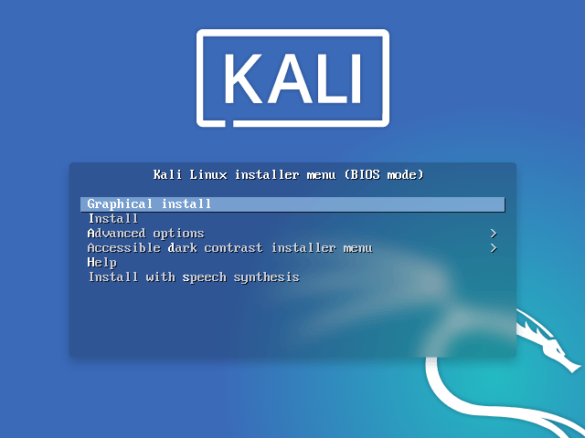
Selected English Language
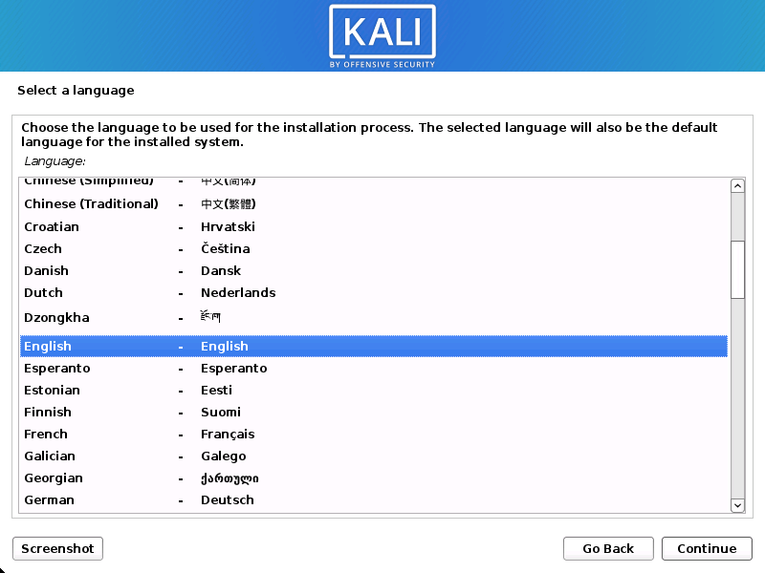

Select your location
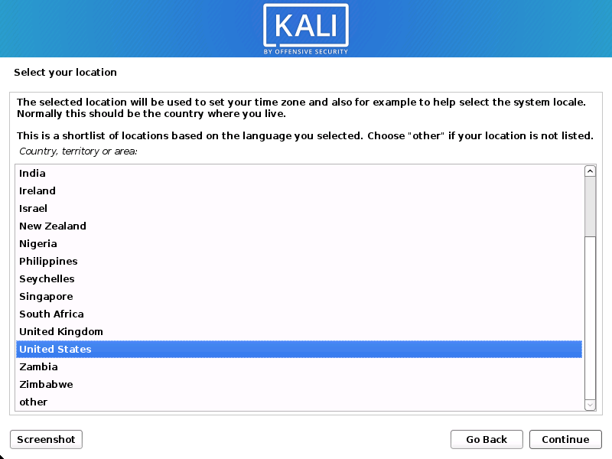
Set your hostname
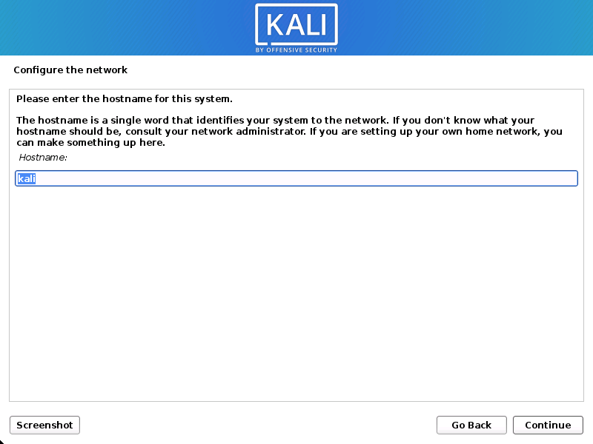

Set your domain name
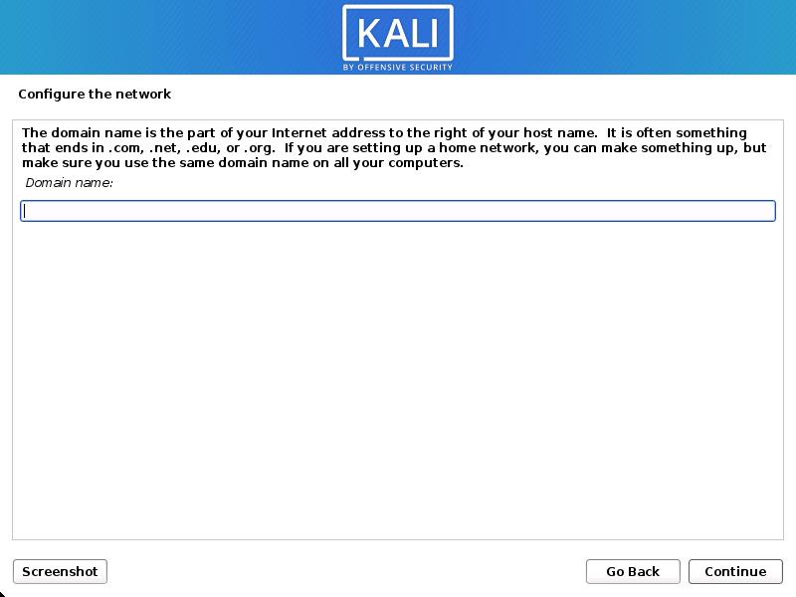
Set username
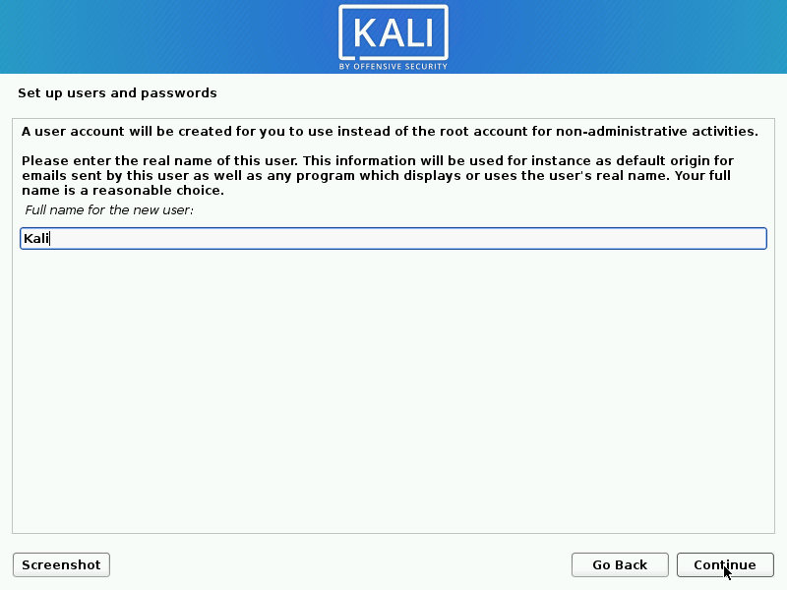

Set password
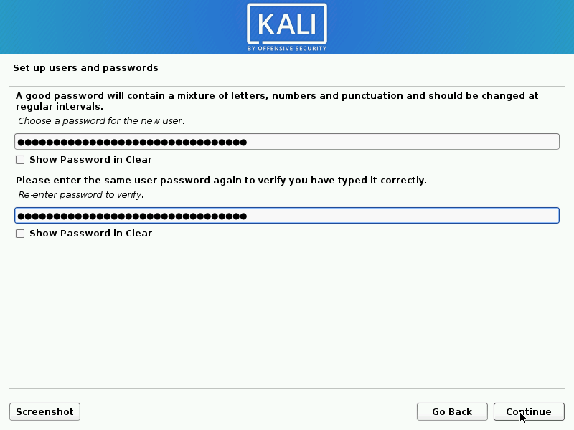
Now configure your clock
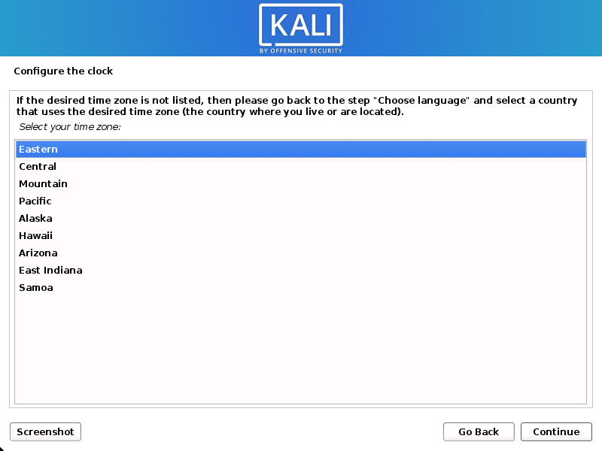
Select disk portions
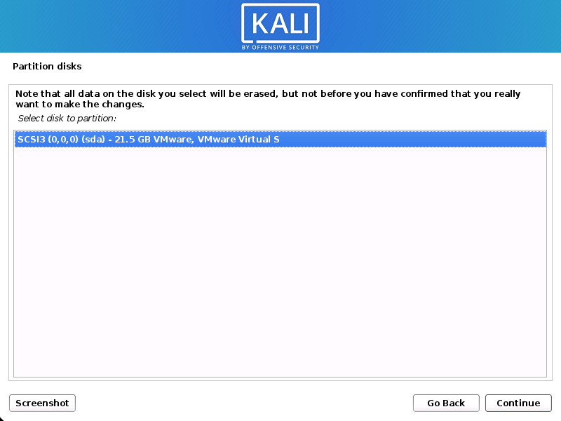
Select recommended setting
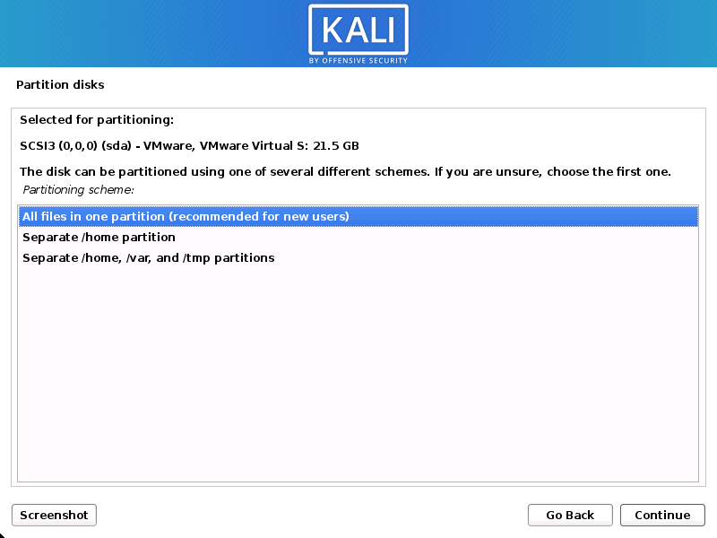
Finish formatting
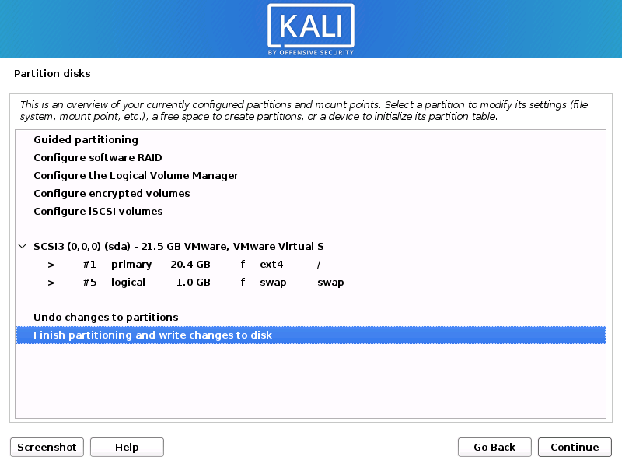
Select disk changes YES
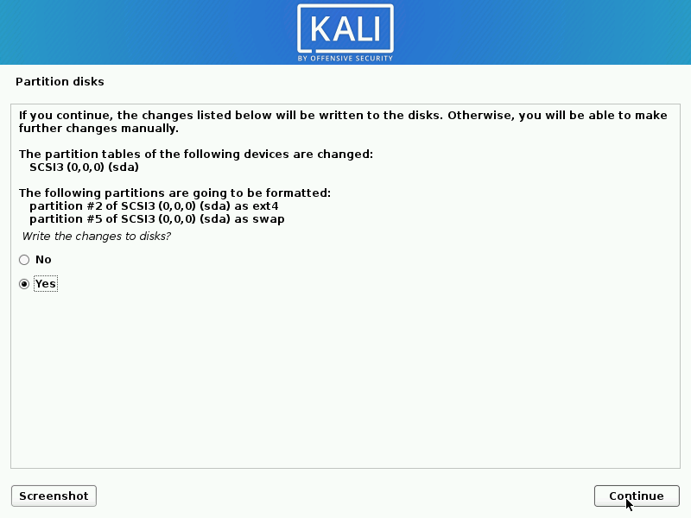
Select continue and finish the setup
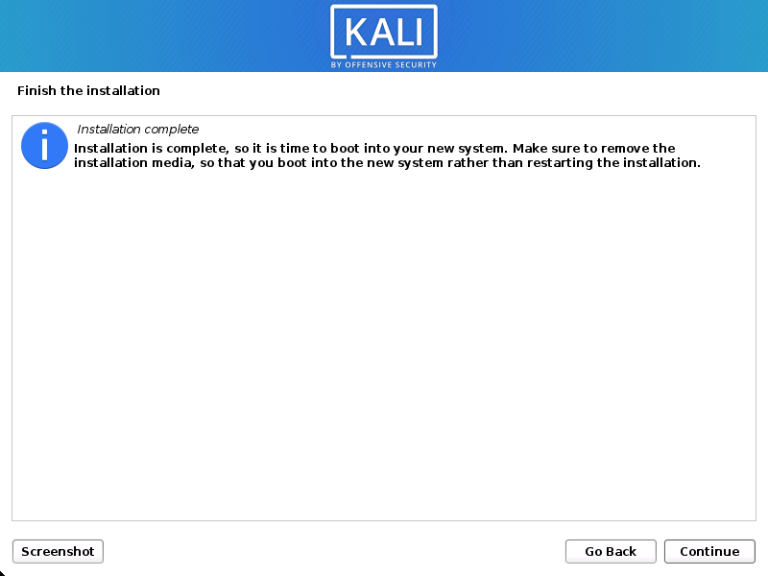
Now reboot and your virtual machine is ready to use.

Post Installation
Update system: sudo apt update && sudo apt upgrade

